**Reply to editors and reviewers**

We thank the editorial board for the opportunity to revise our manuscript. We also appreciate the reviewers' comments; their detailed reading of the manuscript and many suggestions that have improved the article. Our responses to the editors and reviewers’ comments are outlined below in blue with editors and reviewers’ comments in black.

**Editorial requests**

We note that your manuscript currently does not include a statement of Ethics Approval. Please include an ethics statement in your “Methods” section. For further guidance, please see our authors hub: <https://authors.bmj.com/policies/research-ethics/>

We have included a statement of Ethics Approval in the manuscript under the Methods section.

Please revise the title of your manuscript to include the research question, study design and setting. This is the preferred format of the journal.

The title has been revised and now read as “The uneven state-distribution of homicides in Brazil and their effect on life expectancy, 2000-15: A cross-sectional mortality study”

We note currently your manuscript does not include a “Data Sharing” statement, please include a data sharing statement at the end of your paper in line with BMJ Open's new data policy. Please see our Instructions for Authors for further guidance: <https://bmjopen.bmj.com/pages/authors/#Data_Sharing>

We have included a Data Sharing statement at the end of the manuscript:

**Data sharing statement:** This analysis used publicly available data. All data and program scripts are available at <https://github.com/jmaburto/Homicides-and-life-expectancy-in-Brazil>

Please complete and include a STROBE checklist, ensuring that all points are included and state the page numbers where each item can be found: the checklist can be downloaded from here: <https://www.strobe-statement.org/index.php?id=available-checklists>

The STROBE list has been included.

No contributorship statement: Please provide a “Contributorship statement” in your main document file as shown in ScholarOne.

We have included a contribution statement.

Patient and Public Involvement:

We have included a patient statement.

**Reviewer: 1**

Dr. Claudio Dávila-Cervantes, Facultad Latinoamericana de Ciencias Sociales Mexico

Please state any competing interests or state ‘None declared’:

None declared

Comments to the Author

In this paper, the authors aimed to study the impact of homicide mortality on changes in Brazilian life expectancy. I consider that the topic is of interest with potential public health implications. It is a well-written paper which explores an important subject. The methods are well explained, clear and respond to the primary goals of the study. The results are clearly stated and can be fully reproducible as the data and methods are available at a public repository. However, I have some minor suggestions to help improve the quality of the report.

We thank the reviewer for his careful reading of the paper and the suggestions provided to improve the article.

The goal of the paper is to study the impact of homicide mortality on changes in Brazilian life expectancy for men and women separately. However, this separation by gender should be previously addressed in the introduction; maybe by mentioning the differences in both the life expectancy between males and females, as well as homicide mortality rates. This could improve the introduction giving the reader a more complete context regarding the main objective of the paper.

Thank you for this suggestion. We have now included a sentence highlighting that females tend to have higher life expectancy than males and that homicide rates in Latin America are around 10 times higher for males. We included in the introduction:

*“In addition, females tend to have higher life expectancy than males in Brazil, 78.7 and 71.6 years respectively in 2015, and homicide rates among males are ten times higher (Briceno-León et al 2008).”*

Reference: Briceño-León, Roberto, Andrés Villaveces, and Alberto Concha-Eastman. ‘Understanding the Uneven Distribution of the Incidence of Homicide in Latin America’. *International Journal of Epidemiology* 37, no. 4 (1 August 2008): 751–57. <https://doi.org/10.1093/ije/dyn153>.

The authors mention on page 5 line 24, that “The high mortality risk from homicides has the potential to reverse gains in life expectancy, as has been reported in other Latin American countries13.” However, they only refer to one study in Mexico. This could be easily addressed by referring that the reverse gains in life expectancy have been reported in Mexico, and not refer to other Latin American countries, or also refer to the study in Venezuela that is later referred.

Thank you for this observation, we have replaced the reference to the Mexican study to a multi-country study with a focus on Latin America:

Canudas-Romo, V, and Aburto, JM. ‘Youth Lost to Homicides: Disparities in Survival in Latin America and the Caribbean’. *BMJ Global Health* 4, no. 2 (April 2019): e001275.

In the methods section, the authors present the causes of death classification used to analyze homicides and amenable/avoidable mortality. Yet, they do not explain if all the causes of death (i.e. ischemic heart diseases or lung cancer) are considered amenable in all age-groups. In the first referenced paper, the authors focus on cause-specific mortality under age 75, which is the “accepted” age limit to consider a cause of death as amenable/avoidable in many other classifications. I suggest this is clarified in this section.

We have now highlighted in the limitations section that we use the avoidable mortality classification utilised by the Brazilian Ministry of Health, which considers amenable/avoidable mortality for certain causes below age 75 and that to ensure comparability with their classification we did not consider causes of death amenable to medical service above age 75. To ease the reviewer’s concern, we also added a sentence in the methods section clarifying that we refer to mortality below age 75.

I also suggest the authors to briefly clarify how life tables were constructed.

Because of space restrictions we are not able to describe in detail how to construct a life table, however we have included the reference to Preston et al book which includes a full description of the method we followed. In addition, and since all the software to replicate our results are available, we now refer the readers to the possibility of replicating our calculations of life expectancy by following the programming code provided.

In the results section, the authors show the results of their sensitivity check. This could be further addressed by briefly mentioning how the sensitivity check compares to their main results.

Following your suggestion, we have included the following sentences in the Results section:

*By breaking the study period into three-time segments it becomes clear that violence dynamics are changing continuously, and they vary between states and regions. The largest losses in life expectancy where suffered in the last ten years.*

In the “International context with Latin America” section in the discussion, the authors only cite 2 references that address the impact of violence in life expectancy. This section could be improved by referring to other studies that have reported on the subject. For example:

• Canudas-Romo V, Aburto JM. Youth lost to homicides: disparities in survival in Latin America and the Caribbean. BMJ global health. 2019 Apr 1;4(2):e001275.

• González-Pérez GJ, Vega-López MG, Flores-Villavicencio ME. The increase of firearm mortality and its relationship with the stagnation of life expectancy in Mexico. Ciência & Saúde Coletiva. 2017;22:2861-72.

• González-Pérez GJ, Vega-López MG, Souza ER, Pinto LW. Violence deaths and its impact on life expectancy: a comparison between Mexico and Brazil. Ciência & Saúde Coletiva. 2017;22:2797-809.

• Dávila-Cervantes CA, Pardo-Montaño AM. Violence in Colombia and Mexico: trend and impact on life expectancy of homicide mortality between 1998 and 2015. Public health. 2018 Oct 1;163:1-8.

Thanks for pointing out these additional references. We have added them and also rephrased the paragraph, it now reads:

*Latin America is currently the region with the highest homicide rates globally.12 As in Brazil, similar detrimental findings of the effect of violence on life expectancy have been reported in other Latin American contexts.1 In Mexico the rise in homicides has led to a stagnation in country-wide life expectancy between 2000 and 2010,35 36 with significant subnational variation,17 and was identified as a primary determinant of lifespan inequalities.37 Another study in Venezuela found that an increase in firearm-related deaths led to life expectancy stagnation in 1996-2013.38 In Colombia, while homicides have decreased over the last decade, they still represent a large share of total mortality (around 5%) which is estimated to cause a loss of life expectancy of 2.2 and 0.2 years for males and females, respectively.39 Similar evidence from Brazil at the national level showed that life expectancy could improve 1.5 years for males if homicides were eliminated.40 Other studies report evidence of further adverse impacts of violence on population health beyond mortality and decreases in life expectancy. For example, mental health and perception of vulnerability in contexts of increasing homicide mortality are often unquantifiable.46 Consequently, health systems should be prepared for a future increase in mental health issues due to potential insecurity felt by Brazilians. In light of this, further studies into the population health burden of homicides, beyond just mortality, across Brazilian states are encouraged.*

The discussion of the paper could be improved by discussing the potential causes of the observed rise in homicide mortality in Brazil in the second period, even if it isn’t the goal of the paper. What I mean is that the discussion could benefit if the authors address the socio-demographic context of violence in Brazil and other factors that could explain homicide mortality.

A recent comprehensive literature review showed that in recent years, homicides have increased in regions undergoing an accelerated urbanisation process coupled with slow and unequal economic development. Factors such as poverty, exclusion, and lack of opportunities and safety, are very important drivers for young people engaging in violent behaviours. In certain regions, this may lead young people, especially men, to turn to crime as a profitable and economically attractive option. This may partly explain the increased violence in some states.

We have included the following sentences and reference:

*For example, homicides have increased in regions undergoing an accelerated urbanisation process coupled with slow and unequal economic development.39 Factors such as poverty, exclusion, and lack of opportunities and safety may encourage violent behaviours. In certain regions, this may lead young people, especially men, to turn to crime as a profitable and economically attractive option,39 potentially explaining the increase in violence in some states.*

*Reference:*

Wanzinack, Clovis, Marcos Claudio Signorelli, and Clóvis Reis. ‘Homicides and Socio-Environmental Determinants of Health in Brazil: A Systematic Literature Review’. *Cadernos de Saúde Pública* 34 (29 November 2018): e00012818.

**Reviewer: 2**

Dr. GJ González-Pérez , Universidad de Guadalajara

Please state any competing interests or state ‘None declared’:

None declared

Comments to the Author

In a general sense, I consider that the paper addresses a relevant and necessary topic from a relatively new perspective. However, I consider that some aspects deserve to be reviewed and, where appropriate, modified by the authors.

We are pleased that the reviewer found our article pertinent and thank him for all the suggestions that helped improving the manuscript.

1) Is the research question or study objective clearly defined?

Although the objective is understood and is consistent with the title, after reading the paper I consider that it falls short and does not really reflect what is presented in the document: not only the study “… examines the impact of homicide mortality on changes in life expectancy by state for men and women separately in the period 2000-2015 ", but the behavior of "amenable/ avoidable mortality" is also analyzed: a wide space is devoted to the causes of death studied, results are compared and figures are built. So, the objective should include this aspect

Following the suggestion of the reviewer, we have now rephrased the introduction to reflect that we also study amenable/avoidable causes of death. The sentence now reads:

*In this study we aim to examine causes of death considered avoidable/amenable to medical service, with a focus on homicide mortality, and their impact on changes in life expectancy by state for men and women separately in the period 2000-15.*

Additionally, we have included a subsection in the discussion about IHD and causes amenable to medical service. The paragraphs added are:

***Other causes of death***

*The period 2000-2007 also saw increases in mortality from IHD, again offsetting rising life expectancy due to improvements in mortality from other medically amenable causes, and again mostly concentrated in states in the Northern regions. Additionally, some Northern states saw increases in diabetes mortality over the same period, primarily affecting females. On the other hand, in the period 2007-15, improvements in mortality from IHD and diabetes led to increases in life expectancy among females and males in most states. The extent of subnational variation in the impact of homicides, IHD and diabetes related mortality on life expectancy at birth, with a considerably higher burden in Northern compared to Southern states, demonstrates the persistence of health inequalities in Brazil.29*

*Medically amenable mortality contributed significantly to increasing life expectancy throughout the period from 2000 to 2015. Although in two states, Acre and Maranhão, mortality from amenable causes of death deteriorated between 2000 and 2007, these states recovered and improved life expectancy by reducing mortality attributable to medically amenable causes in 2007-15. Our results mirror findings reported in similar studies. Previous evidence suggests that improvements in primary health care has played an essential role in reducing deaths amenable to health care in Brazil.9 43 Similarly, our study highlights the importance of building a strong healthcare system in the Northern regions to further reduce IHD-related mortality. Comprehensive and community-based health interventions can contribute to further decrease mortality from IHD in areas with high prevalence, such as Northern states of Brazil, through a combination of measures focused on prevention, health care, and follow-up for heart diseases.21*

2) Are the methods described sufficiently to allow the study to be repeated?

From my point of view, the Demographic Methods used in the article (Death Distribution Methods and Decomposition method) should be described in a more explicit and clear way in the methods section -although they are explained in more detail in the appendices-, as it must be clear to the reader what they are based on and how they are used in the study (readers will not necessarily read the appendices).

We thank the reviewer for this observation. We decided to expand on our methodology in the appendix since they would require a considerable amount of the article space to thoroughly explain the DDM and decomposition methods, which would fit better in a demographic paper. The article includes a proper citation to the relevant work where the methods were initially proposed. Moreover, we provide the data and the code to replicate our results. Therefore, we think that including an incomplete explanation in the main manuscript, rather than a complete one in the appendix, could bring more doubt to the reader than clarity. To ease the concern of the reviewer we have extended on our explanation about the DDM methods used. We added the following:

*Death counts registration was evaluated across states in Brazil with traditional demographic methods known as Death Distribution Methods,17 18 since there is evidence of under-reporting of death counts and variation in data quality across regions.19 Over the study period (2000-15) death counts registration improved to over 90% completeness.20 The method is based on population dynamics equations and assesses the coverage of deaths in relation to the population and the quality of the declaration of death information. Whenever necessary, the methods provide an adjustment factor that is used to correct death counts registration in each region and obtain an appropriately adjusted estimate of mortality (See Appendix section 1).* *These methods are commonly used by the United Nations and the Institute of Health Metrics and Evaluation and in several national statistics offices.*

Moreover, there are some points that should be clarified by the authors:

Why were these causes selected and not others? I give a couple of examples: deaths classified as Events of undetermined intention (Y10-Y34) -which the literature suggests are mostly homicides- are not taken into account in the study, when the death figures for this cause in Brazil are almost similar to suicide, and the paper places special emphasis on violence.

We thank the reviewer for this observation. Regarding the event of undetermined intention (Y10-Y34) we prefer to err on the side of caution rather than attribute these unknown deaths to homicides. While some of these may be attributed to homicides, we could not find tangible evidence of this for Brazil. Moreover, these deaths represent about 1% of total deaths between 2000 and 2015, which would not change our results considerably since there was not variation over time.

On the other hand, why else include lung cancer and no other amenable malignant neoplasms, or the chronic obstructive pulmonary disease, obviously related to smoking? It is not that this causes necessarily have to be included, but rather adequately justify the decision that the authors made regarding the selection of causes.

It is true that there are other causes of death that are partly amenable to medical services or considered avoidable in the literature. However, as we explain in the manuscript and to Reviewer 1, we decided to use the classification proposed by the Brazilian Ministry of Health to ensure comparability with their mortality profile. In the limitations section we have highlighted that we use this classification, which considers amenable/avoidable mortality for certain causes below age 75 that best characterise the Brazilian mortality profile.

b) When reviewing Table 2 of the appendix, it is seen that the authors did not take into account the item Y87.0 in the suicides and Y87.1 in the homicides (deaths due to the sequelae of suicides and homicides) This must be explained.

Thank you for this observation. The reason behind our classification is that the group Y87 cannot be disaggregated for all the states in Brazil. The impact that this might have on our results, however, is negligible as deaths classified with this group represent only 0.009% of the total deaths. To ease the reviewer’s concern, we have added a sentence about this in the limitations section:

*In addition, some groups of causes of death are not consistent between states. For example, the group Y87 (deaths due to the sequelae of suicides and homicides) cannot be disaggregated for all the states in Brazil to attribute a share to homicides. The impact that this might have on our results, however, is negligible as deaths classified with this group represent only 0.009% of the total deaths.*

c) Knowing that there is a significant number of deaths (especially those caused by violent acts) with an age not specified, it is not clear what was done to correct this problem

Deaths without information on age at death were distributed proportionally by the observed age profile. We have included a sentence in the methods section.

d) In the “Figure S5 Homicide contributions to changes in life expectancy taking different time periods: 2000-05, 2005-10 and 2010-15”, a three-period analysis -of which nothing is mentioned in the methodology- is exposed and I believe that it is necessary to do it.

We thank the reviewer for pointing this out. We included Figure S5 as a sensitivity check of how the dynamics of violence vary considerably between periods and states. Now we highlight this in the results section and with the following sentence:

*By breaking the study period into three-time segments it becomes clear that violence dynamics are changing continuously, and that they vary between states and regions. The largest losses in life expectancy where suffered in the last ten years.*

e) I think there is some confusion in the periods. For example, in the previous point (d), periods that intersect are mentioned: the years 2005 and 2010 are repeated in two periods and, as they are presented, they are periods of 6 years (not 5); something similar when periods from 2000 to 2007 and 2007 to 2015 are mentioned. Although here it is indicated that “2007-15 runs from middle of 2007 to middle of 2015”, why do not construct periods of 8 years, clearly delimited from 2000 to 2007 and from 2008 to 2015?

We arranged the periods in a way to not exclude information for any year so that the addition of the two periods gives the total change over time. For example, if life expectancy in 2000 is 75 years and in 2005 life expectancy is 77, then the difference between 2000 and 2005 is two years. Consider that life expectancy in 2006 is 78 and in 2010 it is 80, then the difference between 2006 and 2010 is also two years. If we consider the periods 2000-2005 and from 2006-2010 as you suggest, we would not be considering the difference between 2005 and 2006, which is one year. Therefore, in a continuous-time basis, to accurately measure time changes over time, we need to include the overlapping year of 2005, as 2000 to 2005 and 2005 to 2010. For our analysis the sum of both 2000-07 and 2007-15 gives the total change between 2000 and 2015.

3) Are the references up-to-date and appropriate? Although in a general sense the references are appropriate and up-to-date, I consider that the following statements should be reviewed, where I believe that an adequate - or more comprehensive - review of the literature was not made. In the Introduction (page 5), it is mentioned that: “Despite this, the effect of homicides on changes to life expectancy has not been explored in the Brazilian context, a country with over 60 thousand murders reports in 2018. There are at least two articles published on this topic, so I think that statement should be modified:

Beltrão KI, Dellasoppa EE. El designio de los hombres. Años de vida perdidos en Brasil y en sus grandes regiones, 1980 a 2005. Estudios Demográficos y Urbanos 2011; 26(2):299-343.

González-Pérez GJ, Vega-López MG, Souza ER de, Pinto LW. Violence deaths and its impact on life expectancy: a comparison between Mexico and Brazil. Ciência & Saúde Coletiva. 2017;22(9): 2797-809 DOI: 10.1590/1413-81232017229.12172017

We thank the reviewer for pointing out these references. We have amended the sentence and included the Gonzalez-Perez et al reference in the context with other Latin American countries and the article by Betlrao and Dellasoppa in the introduction. The sentence now reads:

*Despite this, the effect of homicides on changes to life expectancy has not been explored in the* ***Brazilian context at the state level in recent periods of time****, a country with over 60 thousand murders reports in 2018.*

In the Discussion (page 8) it is mentioned that “…similar detrimental findings of the effect of violence in life expectancy have been reported in other Latin American contexts”; I believe that there are also various articles and documents beyond those mentioned that have previously addressed this same problem in the Latin American context in the present decade, and I only mention some of them, for the authors' knowledge:

González-Pérez GJ, Vega-López MG, Cabrera-Pivaral CE. Impacto de la violencia homicida en la esperanza de vida masculina de México. Revista Panamericana de Salud Pública. 2012;32(5):335-342.

Dávila-Cervantes CA, Pardo-Montaño AM. Magnitud y tendencia de la mortalidad por homicidios en Colombia y México, 2000-2011. Revista Panamericana de Salud Pública. 2014;36(1):10-16

Dávila Cervantes CA, Pardo Montaño AM. Análisis de la tendencia e impacto de la mortalidad por causas externas: México, 2000-2013. Salud Colectiva. 2016;12(2):251-264.

González-Pérez, G.J., Vega-López, M.G. (2019). Violence, firearms and life expectancy in Mexico. In Anson, J., Bartl, W., Kuleczycki, A. (Eds). Studies in the Sociology of Population. International Perspectives. Switzerland: Springer.

Following your suggestion, we have referenced more studies on the effect of homicides on life expectancy in other Latin American countries including a multi-country study, as well as the cases of Mexico, Colombia, Venezuela and Brazil. In addition, the following was added:

*Latin America is currently the region with the highest homicide rates globally.12 As in Brazil, similar detrimental findings of the effect of violence on life expectancy have been reported in other Latin American contexts.1 In Mexico the rise in homicides has led to a stagnation in country-wide life expectancy between 2000 and 2010,35 36 with significant subnational variation,17 and was identified as a primary determinant of lifespan inequalities.37 Another study in Venezuela found that an increase in firearm-related deaths led to life expectancy stagnation in 1996-2013.38 In Colombia, although homicides have decreased over the last decade, they still represent a large share of total mortality (around 5%), which is estimated to cause a loss of life expectancy of 2.2 and 0.2 years for males and females, respectively.39 Similar evidence from Brazil at the national level showed that life expectancy could improve 1.5 years for males if homicides were eliminated.40 Other studies report evidence of further adverse impacts of violence on population health beyond mortality and decreases in life expectancy. For example, mental health and perception of vulnerability in contexts of increasing homicide mortality are often unquantifiable.46 Consequently, health systems should be prepared for a future increase in mental health issues due to potential insecurity felt by Brazilians. In light of this, further studies into the population health burden of homicides, beyond just mortality, across Brazil’s states are encouraged.*

4) Are the results presented clearly? It seems to me that the presentation of the results in the figures is somewhat confusing. In different spaces of Results, (pages 7 and 8) appear the following annotations inserted in the text:

Thank you for your comment. We are concerned about the reviewer finding the figures confusing since we tried to make them as simple as possible. Below we offer an extended explanation of the figures and we have also added extended captions and notes to them.

Figure 1 [about here]. Changes in life Expectancy at birth in Brazil (in years), by state and period, from 2000 to 2007 and from 2007 to 2015.

Figure 2 [about here] Changes in life expectancy at birth in Brazil related to homicide mortality (in years), by state and period, from 2000 to 2007 and from 2007 to 2015

Figure 3 [about here] Changes in life expectancy at birth in Brazil related to mortality resulting from ischemic heart diseases (in years), by state and period, from

2000 to 2007 and from 2007 to 2015

Figure 4 [about here] Changes in life expectancy at birth in Brazil related to mortality resulting from causes amenable to medical service (in years), by state and period, from 2000 to 2007 and from 2007 to 2015.

However, the titles of what appear to be the 4 figures (pages 13 to 16) are:

Change in life expectancty at birth (years) Contribution to change in life expectancty at birth (years) Contribution to change in life expectancty at birth (years) Contribution to change in life expectancty at birth (years)

What are Figures 1,2,3, and 4? The titles do not match, but they must also be properly reformulated (if these are the figures). And of course, correct "expectancy"

Figure 1 shows the change in life expectancy at birth in the two time periods for which we are interested. For example, the pink dots refer to the change in life expectancy between 2000 and 2007, whereas the blue triangles refer to the change observed between 2007 and 2015. The left column refers to females and the right columns to males. Each row represents a state, which are also grouped by regions. The dashed line at zero represents the situation of no changes in life expectancy over time, whereas dots and triangles to the right (left) of this line correspond to increases (decreases) in life expectancy. The title of this Figure is

“Figure 1. Changes in life Expectancy at birth in Brazil (in years), by state and period, from 2000 to 2007 (pink dots) and from 2007 to 2015 (blue triangles). The dashed line at zero represents the situation of no changes in life expectancy over time, whereas dots and triangles to the right (left) of this line correspond to increases (decreases) in life expectancy.”

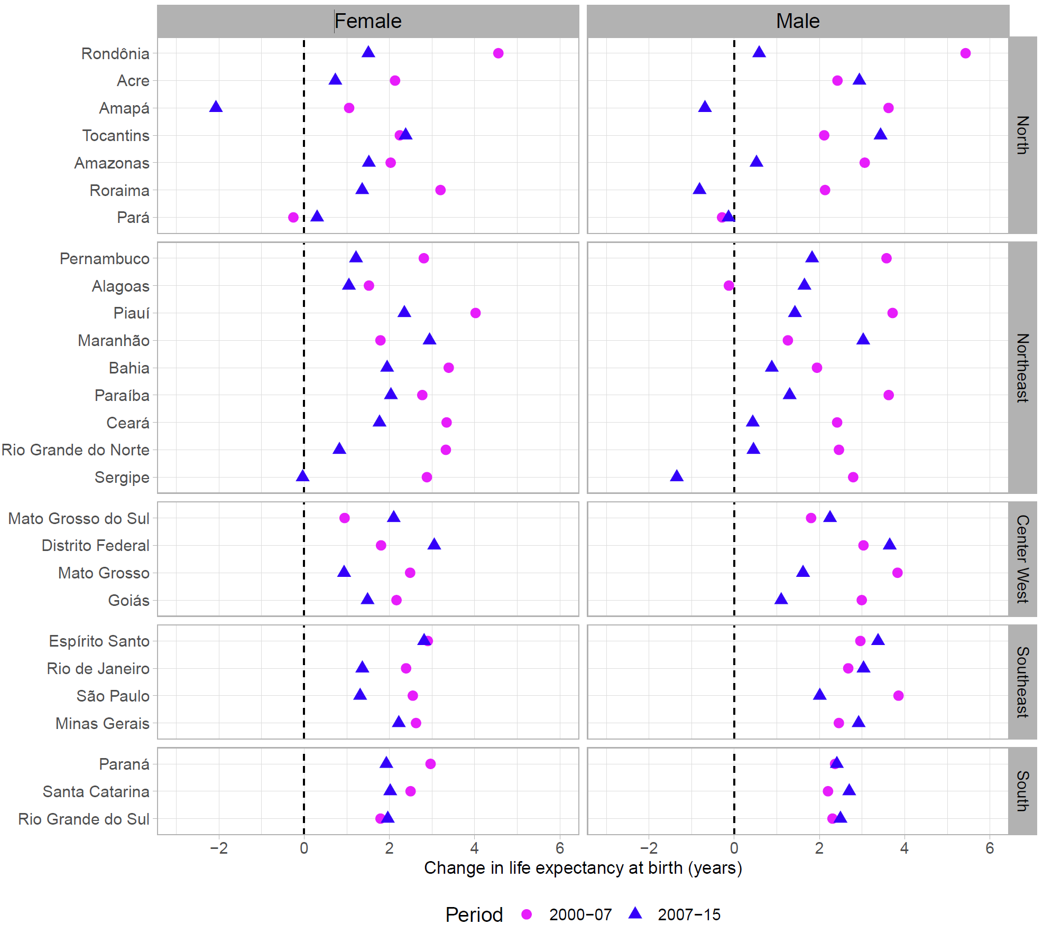

Figures 2, 3 and 4 show cause-specific contributions to changes in life expectancy at birth between 2000 and 2007 in pink dots, and between 2007 and 2015 in blue triangles, respectively. For example, Figure 2 shows that males are more adversely affected by homicides than females, as was expected, with some states such as Sergipe losing almost two years of life expectancy between 2007 and 2015 due to homicides. To ease your concern about the Figures, we have extended the x-axis label to denote the cause of death to which the Figure refers. We have also changed the caption to refer this more clearly:

Figure 2. Contribution of homicides to changes in life expectancy at birth in Brazil (in years), by state and period, from 2000 to 2007 (pink dots) and from 2007 to 2015 (blue triangles). The dashed line at zero represents the situation of no contribution to changes in life expectancy over time, whereas dots and triangles to the right (left) of this line correspond to increases (decreases) in life expectancy due to changes in homicides.

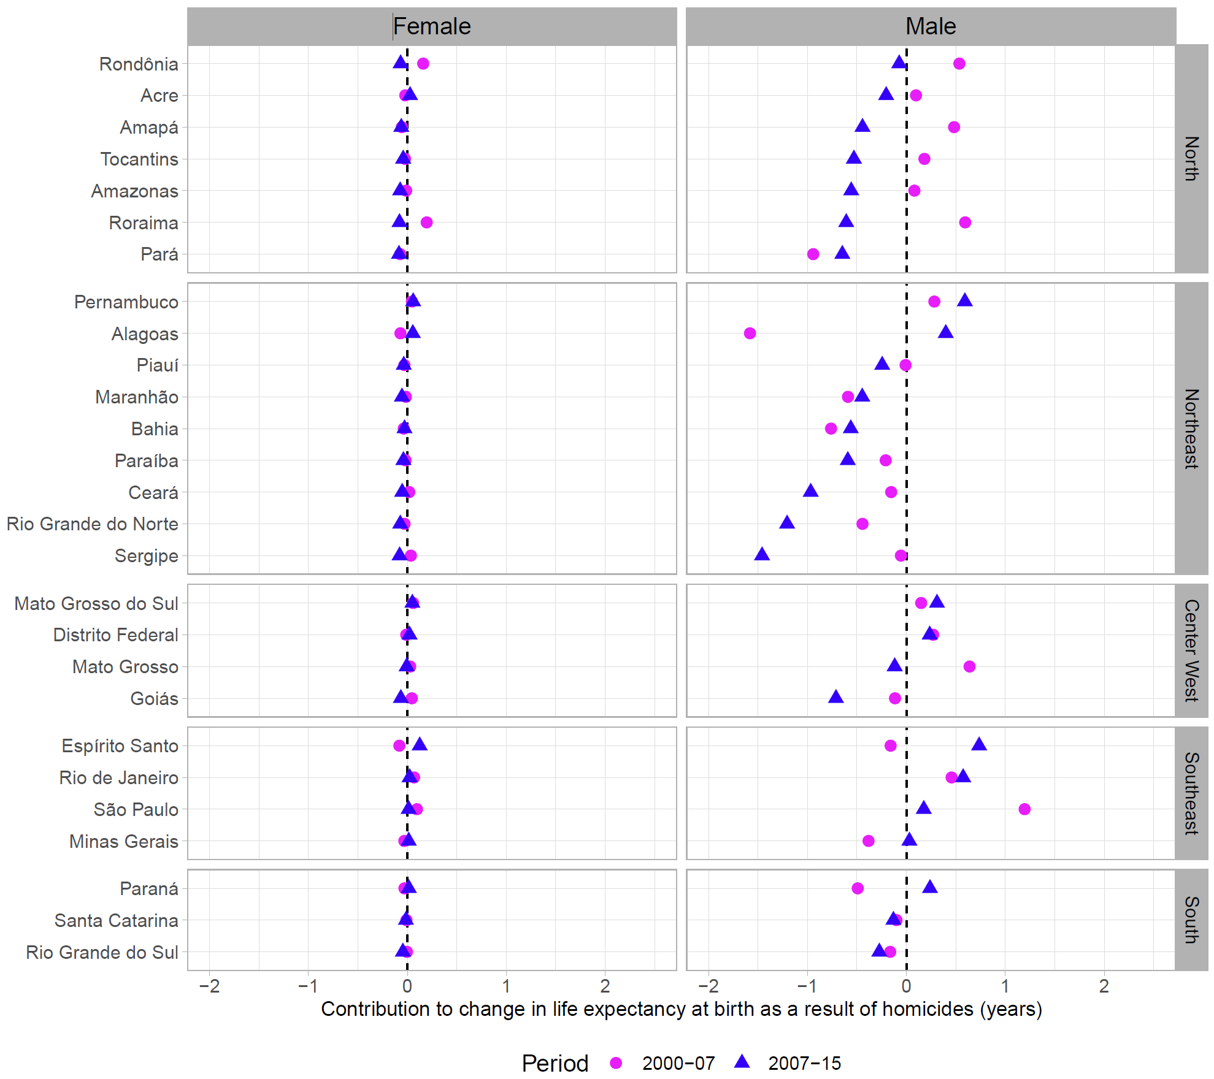

Figure 3. Contribution of ischemic heart diseases to changes in life expectancy at birth in Brazil (in years), by state and period, from 2000 to 2007 (pink dots) and from 2007 to 2015 (blue triangles). The dashed line at zero represents the situation of no contribution to changes in life expectancy over time, whereas dots and triangles to the right (left) of this line correspond to increases (decreases) in life expectancy due to changes in IHD.

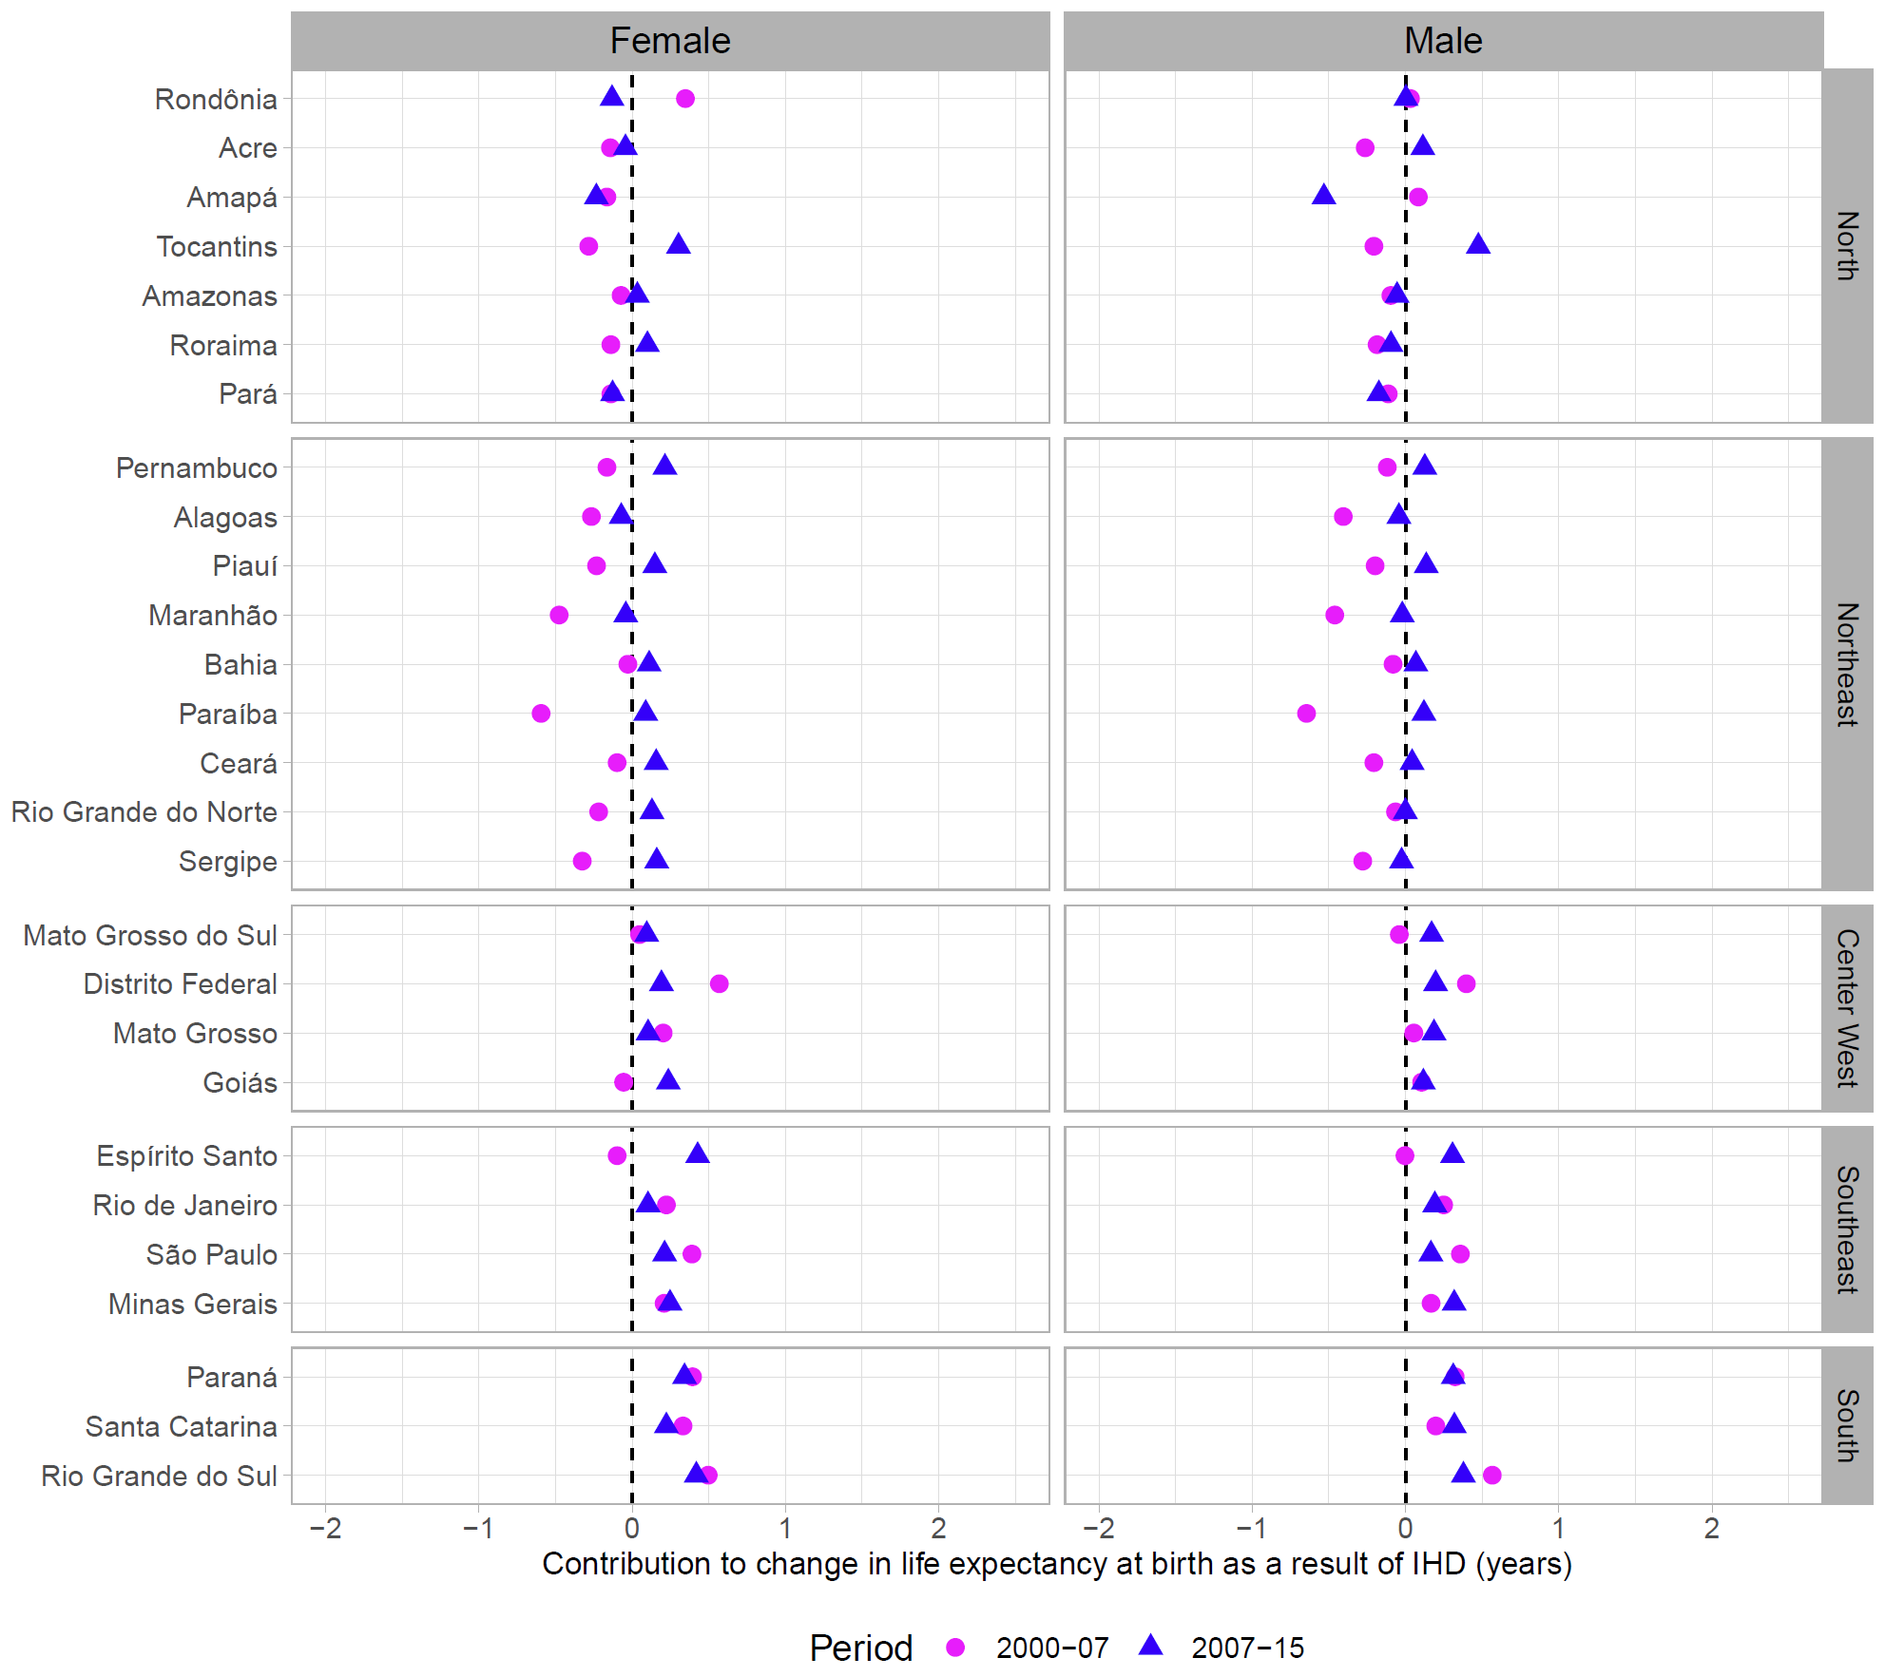

Figure 4. Contribution of causes amenable to medical service to changes in life expectancy at birth in Brazil (in years), by state and period, from 2000 to 2007 (pink dots) and from 2007 to 2015 (blue triangles). The dashed line at zero represents the situation of no contribution to changes in life expectancy over time, whereas dots and triangles to the right (left) of this line correspond to increases (decreases) in life expectancy due to changes in causes amenable to medical service.

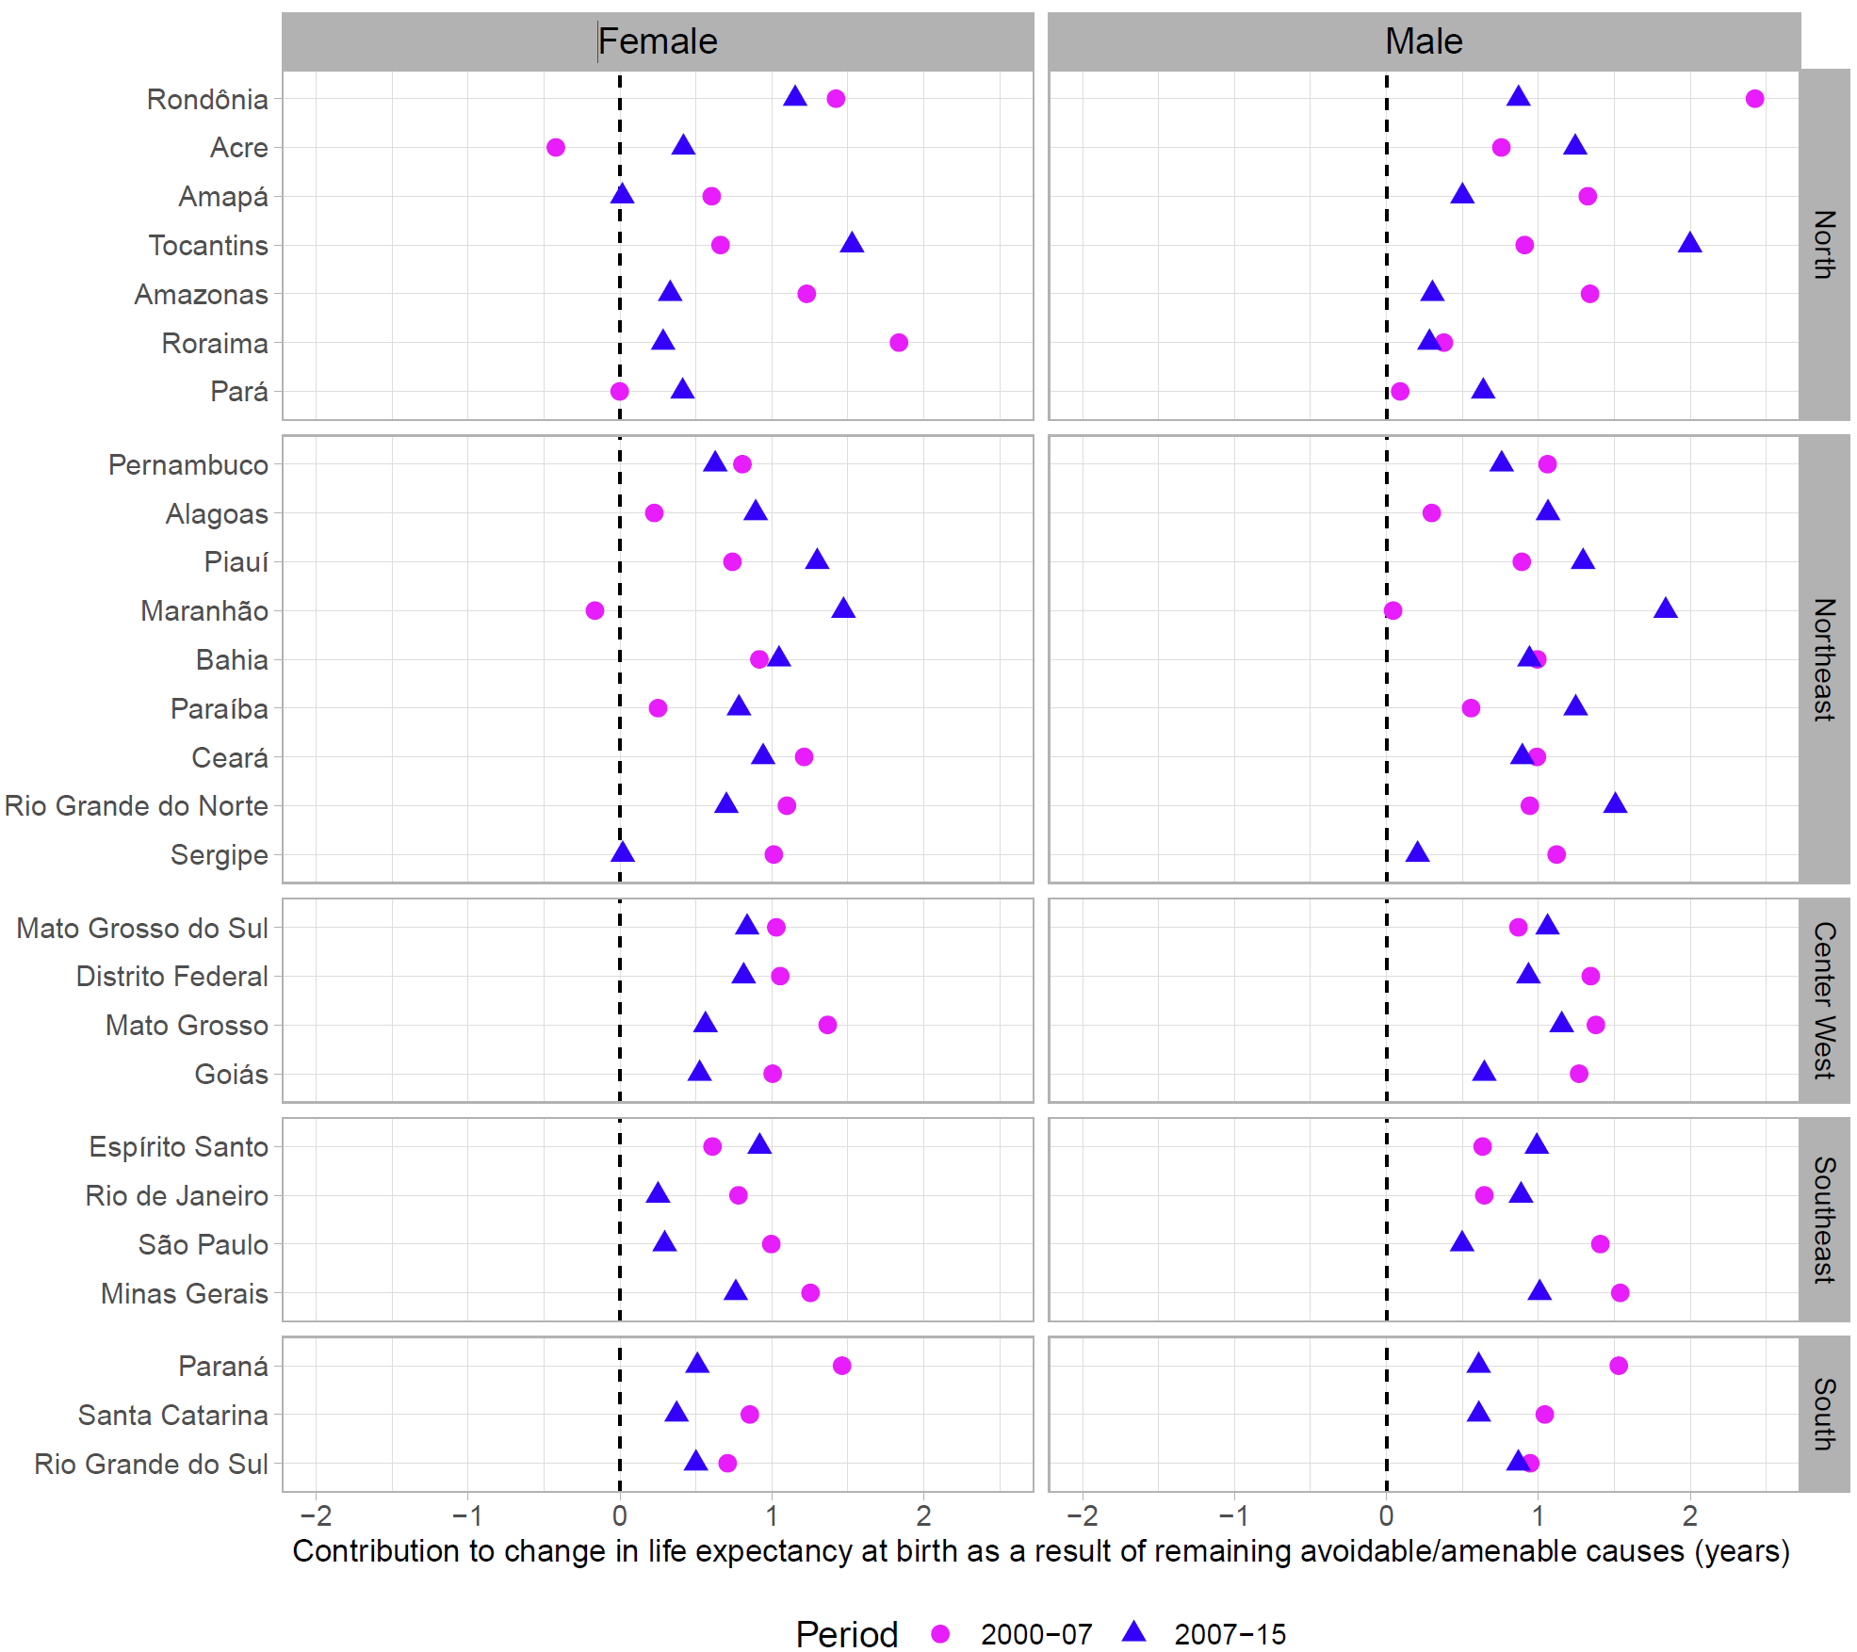

On the other hand, from my point of view, some of the figures for the appendix (perhaps 4 or 5) could be incorporated into the document: these figures, if they are mentioned in the results and discussed, is because they are important, and not should go in an appendix. According to the rules of the journal, up to 5 figures are allowed.

The 4 Figures presented in the main manuscript highlight the most important results of our decompositions. We provide contextual information in the appendix to make smoother the narrative. For example, Figures 4 and 5 of the appendix show the same information as Figure 2 but in different ways, simply to make the point of temporal and regional variations. We, therefore, think that they should be in the appendix rather than in the main manuscript.

Finally, it would seem to me that if the study is designed to show interstate differences, especially in relation to homicides, the discussion should address in more detail why some states have better results (Minas Gerais, Sao Paulo, for example) than others. (Sergipe).

The aim of our article is, indeed, to show state-level differences in Brazil. States with higher proportion of ethnically mixed and black populations suffer the highest levels of violence. We have included in the manuscript a paragraph highlighting the potential role of ethnicity. In addition, in the violent states social inequality and drug trafficking are important factors determining variation in violent mortality withing states in Brazil. However, a limitation is that we are not able to accurately disentangle this in our study. We have added the following:

*Evidence suggests that violent death varies considerably by ethnicity, whereby black and ethnically mixed males are at a higher risk of being victims of violent crime.34 35 In 2007, 55% of the total homicides among males were among mixed race individuals, while 8****.****2% were among black males. Poverty, social inequality and drug trafficking are important factors determining variation in violent mortality within Brazil’s states.36-38 For example, homicides have increased in regions undergoing an accelerated urbanisation process coupled with slow and unequal economic development.39 Factors such as poverty, exclusion, and lack of opportunities and safety may encourage violent behaviours. In certain regions, this may lead young people, especially men, to turn to crime as a profitable and economically attractive option,39 potentially explaining the increase in violence in some states. In this study, we were unable to disentangle the effect of changes in homicide mortality on life expectancy changes by ethnicity or socioeconomic status within states due to the lack of data disaggregated by these levels for long periods of time.*

In addition to the previous paragraph we have also added sentences highlighting the role of public health as an approach to violence:

*There is a need for increased attention and approaches to violence as a public health problem. During the health transition, the emphasis of health care shifted from acute to chronic care without incorporating violence as a dimension of health care. Latin America, including Brazil, is currently the region with the highest homicide rates globally.13 Homicide mortality in Latin American countries is strongly associated with political instability, economic inequality, social segregation, and drug trafficking. We show that in Brazil there is a need for state-specific interventions to change the cultural, economic and social conditions associated with risk factors that trigger the surge of violence.*